**Project Plan**

**Team Collaboration System for Mobility Water Monitoring**

**By**

**Mr. Peerapong Chompootepa 542115044**

**Mr. Worrasete Tansurat 542115056**

**Department of Software Engineering**

**College of Arts, Media and Technology**

**Chiang Mai University**

**Project Advisor**

**____________________________**

**Ms.Siraprapa Wattanakul**

**Document History**

|  |  |  |  |  |  |
| --- | --- | --- | --- | --- | --- |
| **Document Name** | **Detail** | **Status** | **Date** | **View able** | **Reviewer& Responsible** |
| **TCS-Project Plan-V0.1.docx** | -Introduction  -Schedule and Milestones | Draft | 10/01/15 | SW | PC, WT. |
| **TCS-Project Plan-V0.2.docx** | -Update Introduction  -Infrastructure  -Quality Planning  -Estimated Effort and Costs  -Version Control Strategy | Draft | 12/01/15 | SW | PC, WT. |
| **TCS-Project Plan-V0.3.docx** | -Update Infrastructure  -Management Procedures  -Estimate Duration of Tasks | Draft | 13/01/15 | SW | PC, WT. |
| **TCS-Project Plan-V0.4.docx** | -Update Quality Planning  -Identification of Project Risks | Draft | 15/01/15 | SW | PC, WT. |
| **TCS-Project Plan-V0.5.docx** | - Monitoring and Control | Draft | 15/01/15 | SW | PC, WT. |
| **TCS-Project Plan-V1.0.docx** | Update Document | Release | 16/01/15 | SW | PC, WT. |

**\* SW = Ms.Siraprapa Wattanakul**

**\* PC = Mr.Peerapong Chompootepa**

**\* WT = Mr.Worrasete Tansurat**

Table of Contents

**Chapter 2-1 | Introduction** 5

1.1 Identification 5

1.2 Project Overview 5

1.2.1 Scope 5

1.3 Document Overview 5

1.4 Work Products to be Develop 7

1.4.1Deliverable 7

1.5 Acronyms and Definition 8

1.6 User’s Information 9

**Chapter 2-2 | Infrastructure** 10

2.1 Software Acquisition Plans 10

2.1.1 Design Tools 10

2.1.2 Development Tools 10

2.1.3 Configuration Management Tools 10

2.1.4 Document Tools 10

2.1.5 Testing Tools 10

2.2 Hardware and Material Resources 10

**Chapter 2-3 | Management Procedures** 12

3.1 Project Team Structure 12

3.2 Monitoring and Controlling Mechanism 13

3.2.1 Software Development Model 13

**Chapter 2-4 | Quality Plan** 14

4.1 Quality Factors 14

4.1.1 Product Operation Factors 14

4.1.2 Product Revision Factors 14

4.1.3 Product Revision Factors 14

4.2 Reviews/Responsibility 14

4.3 Testing 15

4.4 Software Development Standard 15

4.4.1 ISO29110 for Very Small Entity (VSE) 15

**Chapter 2-5 | Estimated Duration of Tasks** 17

5.1 Project Schedule 17

5.2 Project Estimation 19

5.2.1 Duration 19

**Chapter 2-6 | Estimated Effort and Cost** 21

6.1 Cost 21

**Chapter 2-7 |Monitoring and Control** 22

7.1 Re-Plan Procedure 22

7.2 Team Meeting 22

**Chapter 2-8 | Version Control Strategy** 23

8.1 Configuration Management 23

8.1.1 Naming Conversion 23

8.1.2 Project Repository 23

8.1.3 Configuration Item Table 23

8.1.4Backup Plan 24

8.2 Change Management 24

**Chapter 2-9 | Identification of Project Risks** 25

9.1 Risk Management 25

9.2 Project Risk 26

# Chapter 2-1 | Introduction

## 1.1 Identification

The Project Management Plan is the document for planning, scheduling activities and provide for guide team project manager. The Project Management will lead us to see specific project reach fruition and allow us to work with it and see a project through from start to finish.

## 1.2 Project Overview

Team collaboration system for mobility water monitoring application is developed for the chemical analysis of the water quality which makes it easy for collectors working as a team. The system separates in two parts. The first part is web application, all user can use web application to view the test result. Administrator can create the project and manage the member in the system and also select members to create the new team. The team leader has a role to manage the involved project which is assigned by administrator. The application can see the team members and their responsibility in each of projects. For example, team leader can assign the work location to each collector by marking the pin on the Google Maps and also can review the test result sent from the collector. The second part is mobile application, a part of team leader and collector. Collector can use the mobile application to collect the data, then the application will send the data to calculation component containing the calculating algorithm (produced by I-ANALY-S-T). The system returns the test result from chemical analysis. The status will update automatically when user send the test result. After that, team leader can review the test result by marking the status to finish or recollect on both mobile application and web application.

### 1.2.1 Scope

The TCS is developed in both mobile application and web application and also extended functions of the existing mobile software to have further completion for team collaboration. There are 6 main features of TCS are shown below:

Feature 1: Authentication and member management system

Feature 2: Project management

Feature 3: Map location management

Feature 4: Water parameter calculation

## 1.2.2 User Characteristics

The system divided users into 3 groups. Information and characteristics of each group are listed below.

**Administrator**

Administrator can access to the system on web application for managing the system (profile, project and team member). When the collector sends register request on mobile application, administrator can see a list of new collector requests and also can select to approve or decline the account. Administrator is able to create or modify the new project with selects team and defines team leader into the project. Before to create the project, administrator can create a team by select members existing in the system. And also the administrator can view relevant information such as team information and project information.

**Team leader**

Team leader can access to the system both of web application and mobile application. Team leader can see the information of each project and able to manage team that he is the team leader includes editing name, adding team member and removing team member. On the part of the project, team leader can see the information of each project on web application and able to assigns work by marking location on Google Maps to the collector. Each project will show the status of the work for the members to know the progress of the work.

**Collector**

Collector needs to be registered an account on mobile application and wait for administrator approves an account request before login to the system. Collector can view work assignment assigned by team leader. Collector can collect samples of the water sources that team leader assign location by Google Maps. Collector must update the status of the work and send test result to the web service.

**Progress Report I consist of**

**Feature 1: Authentication and member management system**

* Administrator, Team leader, and Collector can log in to the system on web application.
* Administrator, Team leader, and Collector can logout from the system on web application.
* Team leader and Collector can log in to the system on mobile application.
* Team leader and Collector can logout from the system on mobile application.
* New collector can send register request to the administrator on mobile application requesting to be a member.
* Administrator can view list of new collector requests sorted by date on web application.
* Administrator can search a new collector request by using new collector name on web application.
* Administrator can select to approve or decline new member on web application.
* Administrator can create a team which contains a team name, team leader and team members on web application.
* Administrator and team leader can view list of team sorted by team name on web application.
* Administrator and Team leader can search the team by using team name on a web application.
* Administrator and Team leader can modify the selected team information on web application.
* Administrator and Team leader can view the selected team information includes a team name, team leader name, and list of members on web application.
* Administrator can remove a team out of the system on web application.
* Administrator, Team leader, and Collector can edit profile information which includes a name, password and telephone number on web application.

**Feature 2: Project management**

* Administrator can create the project includes a project name, project description, and team on web application.
* Administrator can remove the project out of the system on web application.
* Administrator can view list of all project sorted by created date of the project on a web application
* Team leader and Collector can view list of the involved projects sorted by created date of the project on a web application and mobile application.
* Administrator, Team leader and Collector can search the project by using project name on web application.
* Administrator can modify the project information includes editing project name, editing project description, and changing a team on web application.
* Administrator can view detail of selected projects information which consisting of map with assigned pins and location information on a web application.
* Team leader and Collector can view detail of selected projects information which consisting of map with assigned pins and location information of the selected project on a web application and mobile application.
* Administrator can view list of water parameter of the selected member sorted by date on a web application.
* Team leader and Collector can view list of water parameter of the selected member sorted by date on a web application and mobile application.

**Progress Report II consist of**

**Feature 3: Map location management**

* Team leader can assign work location on Google map to each collectors on web application.
* Team leader and Collector can view the direction to the selected location on Google Maps on mobile application.
* Team leader and Collector can view location information of each assigned pin on selected project by pressing on the pin on mobile application.

**Feature 4: Water parameter calculation**

* Collector can add water parameter to collect the test data on mobile application.
* Collector can delete water parameter on mobile application.
* Collector can choose the image from camera roll or take a new photo to collect RGB value with the test result on mobile application.
* Collector can input data to let the system calculate the test result based on standard color scale on mobile application.

**Progress Report III consist of**

**Feature 5: Parameter result tracing**

* Administrator can view detail of test result of selected water parameter on a web application.
* Team leader and Collector can view detail of test result of selected water parameter on a web application and mobile application.
* Team leader can mark status of the selected water parameter to “Recollect” on a web application and mobile application.
* Team leader can mark status of the selected water parameter to “Finish” on a web application and mobile application.

**Feature 6: Messaging system**

* Team leader and Collector can send the message to each other via group message within the team on a mobile application.

## 1.3 Document Overview

The purpose of the Team collaboration system for mobility water monitoring project plan is to guide project team members during the development of Team collaboration system for mobility water monitoring project.

## 1.4 Work Products to be Develop

### 1.4.1Deliverable

|  |  |  |  |  |
| --- | --- | --- | --- | --- |
| **No.** | **Deliverables/Release** | **Media** | **No. of Copies** | **Date** |
| 1 | **Project Proposal**  • Team collaboration system for mobility water monitoring  Version 1.0 | Document | 3 | January |
| 2 | **Progress Report I**  • Project Management Plan Version 1.0  • Software Requirement Specification  Version 1.0  • Software Design Document Version 1.0  • Test Plan Version 1.0  • Traceability Record Version 1.0  • Software Version 1.0 | Document | 3 | February-March |
| 3 | **Progress Report II**  • Project Management Plan Version 2.0  • Software Requirement Specification  Version 2.0  • Software Design Document Version 2.0  • Test Plan Version 2.0  • Traceability Record Version 2.0  • Software Version 2.0 | Document | 3 | March-April |
| 4 | **Progress Report III**  • Project Management Plan Version 3.0  • Software Requirement Specification  Version 3.0  • Software Design Document Version 3.0  • Test Plan Version 3.0  • Traceability Record Version 3.0  • Software Version 3.0 | Document | 3 | April-May |

## 1.5 Acronyms and Definition

**Acronyms**

PMP Project Management Plan

SRS Software Requirements Specification

URS User Requirements Specification

TCS Team Collaboration System for Mobility Water Monitoring

SW Siraprapa Wattanakul

PC Peerapong Chompootepa

WT Worrasete Tansurat

**Definition**

|  |  |
| --- | --- |
| Acceptance Test | Test activities for sample checks to verify that a system (or product, solution) has the right quality for development or usage. Often acceptance test is done by the customer. [IEEE90] |
| Feature | Transformation of input parameters to output parameters based on a specified algorithm. It describes the functionality of a product. Used for requirements analysis, design, coding, testing or maintenance. [IEEE90] |
| IEEE | Institute for Electrical and Electronics Engineers. Biggest global interest group for engineers of different branches and for computer scientists. [IEEE90] |
| Plan | A documented series of tasks requires meeting an objective, typically including the associated schedule, budget, resources, organizational description and work breakdown structure. [IEEE90] |
| Project Management | The application of knowledge, skills, tools, and techniques to project activities in order to meet or exceed stakeholder needs and expectations from a project. [IEEE90] |
| Project plan | A formal, approved document used to guide both project execution and project control. The primary uses of project plan are to document planning assumptions and the decision, to facilitate communication among stakeholders, and to document approved scope, cost, and schedule baseline. [IEEE90] |
| Risk | An uncertain event or condition that, if it occurs, has a positive or negative effect on a project's objectives. It is a function of a probability of occurrence of a given threat's occurrence. [IEEE90] |
| Risk Management | The systematic application of management policies, procedures and practices to the tasks of identifying, analyzing, evaluating, treating and monitoring risk. [IEEE90] |

## 1.6 User’s Information

| **Name** | **Responsibility** |
| --- | --- |
| lecturer of faculty of science | Provides the requirements for this project |
| N/A | To be an administrator of the system |
| N/A | To be an user of the system |

# Chapter 2-2 | Infrastructure

## 2.1 Software Acquisition Plans

### 2.1.1 Design Tools

* Photoshop CS6
* Adobe Dreamweaver CS6
* Pencil
* Visual Paradigm
* Visio 2013

### 2.1.2 Development Tools

* Eclipse
* PHP Storm 7.1.3

### 2.1.3 Configuration Management Tools

* GitHub
* Google Drive

### 2.1.4 Document Tools

* Microsoft Word 2013
* Google Doc.

### 2.1.5 Testing Tools

* Smart Phone Samsung (Android Device)
* Notebook with Google chrome or Firefox browser
* Host Server

## 2.2 Hardware and Material Resources

* **Internet**
* **Computers**
  + HP Probook 4530s
    - Processor: Intel® Core™ i5-2430M CPU @ 2.40GHz 2.40GHz
    - RAM: 8.00 GB
    - Operating System: Windows 7 Ultimate
  + Asus K550J
    - Processor: Intel® Core™ i7-2410M CPU @ 3.5GHz 2.30GHz
    - RAM: 4.00 GB
    - Operating System: Windows 7 Ultimate
* **Mobile phones:** Android Operating System
  + Samsung Galaxy Ace Plus S7500
    - CPU: Quad-core 1.0 GHz Cortex-A7
    - RAM: 1.0 GB
    - Operating System: Android 2.3 Gingerbread

# 

# Chapter 2-3 | Management Procedures

## 3.1 Project Team Structure

|  |  |  |
| --- | --- | --- |
| **Participants** | **Roles** | **Responsibility** |
| Peerapong Chompootepa  and  Worrasete Tansurat | • Developer  • Tester  • Reviewer | •         Create document  - Proposal  - Project Plan  - SRS  - Software Design Document  - Test Plan  - Test Record  - Traceability Record  •         Develop software  •         Test software  •         Review document and software  •         Mange change |

## 

## 3.2 Monitoring and Controlling Mechanism

### 3.2.1 Software Development Model

The TCS project is developed using Iterative life cycle model which is the concept of dividing the work into small pieces.

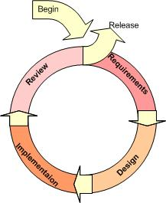

**Figure 1:** Iterative model

An iterative model is used to reduce the risk of development. The development begins by specifying and implementing just part of the software, which can then be reviewed in order to identify further requirements. During each of iteration, the development module goes through the requirements, design, and implementation and testing phases. Each subsequent release of the module adds function to the previous release. The process continues till the complete system is ready as per the requirement.

An iterative life cycle model can accommodate changes by stakeholder feedback to refine requirements and design. The developers can build and improving the product step by step causes we can track the defects at the early stages.

# 

# Chapter 2-4 | Quality Plan

## 4.1 Quality Factors

### 4.1.1 Product Operation Factors

**Correctness**

The software should provide more than 80% of data as the user requested correctly.

**Usability**

The software should provide understandable and easy-to-use GUI and language.

**Reliability**

The software should perform with more than 80% of usual activities, and with less than 10% of failure.

**Integrity**

The software should be able to identify between authorized and unauthorized users, and also between each type of users.

### 4.1.2 Product Revision Factors

**Maintainability**

The software should perform with more than 80% of usual activities, and with less than 10% of failure.

**Testability**

The software should be 100% tested of it defined routine and functionality.

### 4.1.3 Product Revision Factors

**Reusability**

More than 20% part of finished software product should able to be reused in future development.

## 4.2 Reviews/Responsibility

|  |  |  |  |
| --- | --- | --- | --- |
| **Stage Exit Review** | | | |
| **No.** | **Stage** | **Review Item** | **Responsibility** |
| 1 | The progress report 1 | Project Plan | Peerapong, Worrasete |
| 2 | The progress report 1 | Requirement Specification | Peerapong, Worrasete |
| 3 | The progress report 1 | Architecture and Software Design Document | Peerapong, Worrasete |
| 4 | The progress report 1 | Software Testing | Peerapong, Worrasete |
| 5 | The progress report 1 | Traceability Record | Peerapong, Worrasete |

## 4.3 Testing

|  |  |  |
| --- | --- | --- |
| **Test Process** | | |
| **No.** | **Test** | **Responsibility** |
| 1 | Unit Testing | Peerapong, Worrasete |
| 2 | System Testing | Peerapong, Worrasete |

## 4.4 Software Development Standard

### 4.4.1 ISO29110 for Very Small Entity (VSE)

ISO 29110 is a guide applies to Very Small Entities (VSEs), enterprise, organization, department or project up to 25 people, dedicated to software development. The Guide provides Project Management and Software Implementation process which integrate practices based on the selection of ISO/IEC12207- Systems and Software Engineering -Software Life Cycle process - guidelines for the content of software life cycle process information products (documentation) standards elements.

**4.4.1.1Project Management (PM)**

The purpose of the Project Management process is to establish and carry out in a systematic way the tasks of the software implementation project, which allows complying with the project's objectives in the expected quality, time and costs.

PM objectives

PM.O1. The Project Plan for the execution of the project is developed according to the Statement of Work and validated with the Customer. The tasks and resources necessary to complete the work are sized and estimated

PM.O2. Progress of the project is monitored against the Project Plan and recorded in the Progress Status Record. Corrections to remediate problems and deviations from the plan are taken when project targets are not achieved. . Appropriate treatment is taken to correct or avoid the impact of risk. Closure of the project is performed to get the Customer acceptance documented in the Acceptance Record.

PM.O3. The Change Requests are addressed through their reception and analysis. Changes to software requirements are evaluated for cost, schedule and technical impact.

PM.O4. Review meetings with the Work Team and the Customer are held. Agreements are registered and tracked.

PM.O5. Risks are identified as they develop and during the conduct of the project.

PM.O6. A software Version Control Strategy is developed. Items of Software Configuration are identified, defined and baselined. Modifications and releases of the items are controlled and made available to the Customer and Work Team including the storage, handling and delivery of the items.

PM.O7. Software Quality Assurance is performed to provide assurance that work products and processes comply with the Project Plan and Requirements Specification.

**PM Activities**

The Project Management Process has the following activities:

* PM.1 Project Planning
* PM.2 Project Plan Execution
* PM.3 Project Assessment and Control
* PM.4 Project Closure

**4.4.1.2 Software Implementation (SI)**

The purpose of the Software Implementation process is the systematic performance of the analysis, design, construction, integration and tests activities for new or modified software products according to the specified requirements.

**SI objectives**

**SI.O1** Tasks of the activities are performed through the accomplishment of the current Project Plan.

**SI.O2** Software requirements are defined, analyzed for correctness and testability, approved by the Customer, baselined and communicated.

**SI.O3** Software architectural and detailed design is developed and baselined. It describes the software items and internal and external interfaces of them. Consistency and traceability to software requirements are established.

**SI.O4** Software components defined by the design are produced. Unit test are defined and performed to verify the consistency with requirements and the design. Traceability to the requirements and design are established.

**SI.O5** Software is produced performing integration of software components and verified using Test Cases and Test Procedures. Results are recorded at the Test Report. Defects are corrected and consistency and traceability to Software Design are established.

**SI.O6** A Software Configuration, that meets the Requirements Specification as agreed to with the Customer, which includes user, operation and maintenance documentations is integrated, baselined and stored at the Project Repository. Needs for changes to the Software Configuration are detected and related Change Requests are initiated.

**SI.O7** Verification and Validation tasks of all required work products are performed using the defined criteria to achieve consistency among output and input products in each activity. Defects are identified, and corrected; records are stored in the Verification/Validation Results.

**SI activities**

The Software Implementation Process has the following activities:

* SI.1 Software Implementation Initiation
* SI.2 Software Requirements Analysis
* SI.3 Software Architectural and Detailed Design
* SI.4 Software Construction
* SI.5 Software Integration and Tests
* SI.6 Product Delivery

# Chapter 2-5 | Estimated Duration of Tasks

## 5.1 Project Schedule

**5.1.1 Proposal Report**

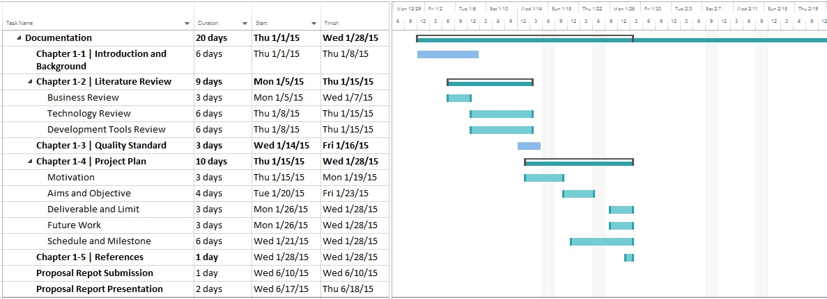

**Figure 2:** Proposal Report

**5.1.2 Progress Report 1**

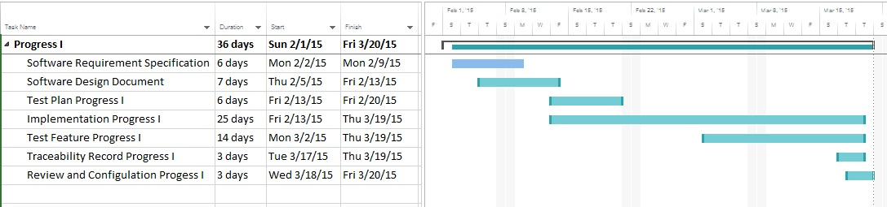

**Figure 3:** Progress Report 1

**Progress Report 1**

* Feature 1: Authentication and member management system
* Feature 2: Project management

**5.1.3 Progress Report 2**

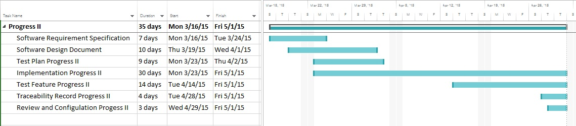

**Figure 4:** Progress Report 2

**Progress Report 2**

* Feature 3: Map location management
* Feature 4: Water parameter calculation

**5.1.4 Progress Report 3**

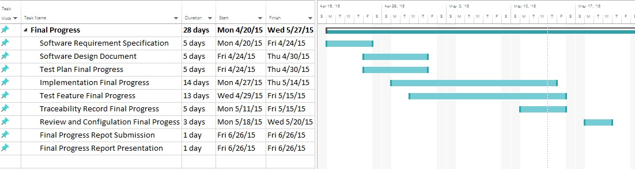

**Figure 5:** Progress Report 3

**Progress Report 3**

* Feature 5: Parameter result tracing
* Feature 6: Messaging system

## Project Estimation

### 5.2.1 Duration

| **Milestone** | **Task** | **Milestone Criteria** | **Planned date** |
| --- | --- | --- | --- |
| 1 | Proposal | -Topic defined | January |
| 2 | Proposal Report | - Proposal reviewed  - Proposal submitted  - Proposal presentation | January |
| 3 | Progress Report I | - Software Requirements Specification  - Software Design Document  - Test Plan Progress 1  - Implementation Progress 1  - Test Feature Progress 1  - Traceability Record Progress 1  - Progress  report 1 submitted  - Progress report  1 presentation | February-March |
| 4 | Progress Report II | - Software Requirements Specification  - Software Design Document  - Implementation Progress 2  - Test Feature Progress 2  - Traceability Record Progress 2  - Progress Report 2 submitted  - Progress report 2 presentation | March-April |
| 5 | Progress Report III | - Software Requirement Specification  - Software Design Document  - Test Plan Progress 3  - Implementation Progress 3  - Test Feature Progress 3  - Traceability Record Progress 3  - Progress  report 3 submitted  - Progress report  3 presentation | May |

**Progress Report 1**

* Feature 1: Authentication and member management system
* Feature 2: Project management

**Progress Report 2**

* Feature 3: Map location management
* Feature 4: Water parameter calculation

**Progress Report 3**

* Feature 5: Parameter result tracing
* Feature 6: Messaging system

# Chapter 2-6 | Estimated Effort and Cost

## 6.1 Cost

|  |  |
| --- | --- |
| **Item** | **Approximately Cost (THB)** |
| Text Book | 1,500 |
| Document Printing | 2,000 |
| litmus test | 100 |
| Host Server | 700 |
| **Total** | **4,300** |

# 

# Chapter 2-7 |Monitoring and Control

## 7.1 Re-Plan Procedure

PM need to monitor the project process performance attributes, work products, deliverables, the actual completion of activities, milestones and compare them against the estimated schedule as documented in the project plan. Any significant deviations for the schedule deviations are identified. PM confirms whether there is delay in the task in critical-path. Effort expended is also monitored throughout the life cycle of the project.

The master plan is updated if at least one of the followings can be seen. Re- planning criteria.

* The project scope has changed
* The estimate has changed
* The actual performance significantly has deviated from plan

## 7.2 Team Meeting

The periodic project review meetings are held as per the frequency defined below. All team members should attend project review meeting and cover the topic of

1. Analyze and discuss the project progress with reference to the planned schedules and resource
2. Discuss the problems of the project.
3. Identify areas of slippage and weakness
4. Decide on preventive and corrective actions.

|  |  |
| --- | --- |
| **Participants** | **Roles** |
| Aj. Sriraprapa Wattanakul | Project Advisor |
| Dr. Kate Grudpan | User Requirements |
| Mr. Peerapong Chompootepa | Development team member |
| Mr. Worrasete Tansurat | Development team member |

# Chapter 2-8 | Version Control Strategy

## 8.1 Configuration Management

### 8.1.1 Naming Conversion

The file naming format that we are going to use for all project documents is   
“[Project Name]-[Document Name]-[Version]”

### 8.1.2 Project Repository

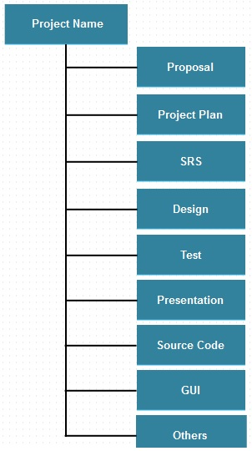GitHub provides users free spaces to easily store and share their photos, documents, information, and even source code. It is like a social network for the programmers.

**List of related document and description**

1. Proposal: contains involved proposal document files
2. Project Plan: contains project plan document files
3. SRS: contains software requirements specifications document files
4. Design: contains design document files
5. Test: contains testing document files
6. Traceability Record: contains traceability record files
7. Presentation: contains presentation files
8. Source Code: contains source code of the project
9. GUI: contains the pictures that will be used as Graphic User Interface of the system.
10. Others: contain pictures, involved and interesting information, etc.

### 8.1.3 Configuration Item Table

|  |  |  |  |  |  |
| --- | --- | --- | --- | --- | --- |
| **No** | **Item** | **File Name** | **File Type** | **Owner** | **Path** |
| 1 | Project Proposal | TCS-Proposal-V2.0 | .docx | PC, WT | / TCS /Proposal |
| 2 | Project Management Plan | TCS-ProjectPlan-V2.0 | .docx | PC, WT | / TCS /Project Plan |
| 3 | Software Requirements Specification | TCSt-SRS-V2.0 | .docx | PC, WT | / TCS /SRS |
| 4 | Software Design Document | TC-SDD-V2.0 | .docx | PC, WT | / TCS /Design |
| 5 | Test Plan | TCS-TestPlan-V2.0 | .docx | PC, WT | / TCS /Test |
| 6 | Test Record | TCS-TestRecord-V2.0 | .docv | PC, WT | /TCS/TestRecord |
| 7 | Traceability Record | TCS-Traceability-V2.0 | .docx | PC, WT | /TCS/ Traceability |

### 8.1.4Backup Plan

|  |  |
| --- | --- |
| Location/Path | /Backup/TCS/* |
| Responsibility | PC |
| Method | To backing up the work products, all related repository in development environment need to be duplicated to destination path |

## 8.2 Change Management

Change Management manages all of the changes in the project during the development process. All of the change requests will be recording into the change management document.

Change management is the process of selecting which changes to encourage, allow, and prevent, according to a set project criteria. This process enables in identifying and managing the origin of the changes, defining critical decision points, and establishing project change management roles and responsibilities.

We have the strategy for manage the changes by following these steps:

1. Identify the change control authority
2. Initiate and record change requests
3. Analyze the change requests
4. Obtain appropriate authorization
5. Track the status of the Change Request to Closure
6. Perform review

# 

# Chapter 2-9 | Identification of Project Risks

## 9.1 Risk Management

The purpose of risk management is to find and control potential problems as early as possible before they actually happen. To minimize the impacts of risks upon projects by forecasting them, it is required to identify the risks systematically and take proactive measures to mitigate the impacts. To identify the project risk following these steps:

1. Identifying risks
2. Evaluate risk and analyze
3. Preparation of risk preventive / handling plans
4. Monitoring risk management plan

Risk shall be evaluated following the procedure below.

Probability occurrence can be

Almost Certain > 80%

Likely 61 – 80 %

Possible 51 – 60 %

Unlikely 41 – 50 %

Rare <= 40 %

Impact can be

Catastrophic > 80%

Critical 61 – 80 %

Marginal 51 – 60 %

Minor 41 – 50 %

Negligible <= 40 %

|  |  |  |  |  |  |  |
| --- | --- | --- | --- | --- | --- | --- |
|  | | Probability **** | | | | |
| A | B | C | D | E |
| Almost Certain | Likely | Possible | Unlikely | Rare |
| Impact **\*\*** | Ct – Catastrophic | **H** | **H** | **H** | **H** | **M** |
| Cr – Critical | **H** | **H** | **H** | **M** | **M** |
| M – Marginal | **H** | **M** | **M** | **M** | **M** |
| Min – Minor | **M** | **M** | **M** | **L** | **L** |
| N – Negligible | **M** | **M** | **L** | **L** | **L** |

Overall risk can be prioritized

H – High Risk

M – Medium Risk

L – Low Risk

## 9.2 Project Risk

|  |  |  |  |  |
| --- | --- | --- | --- | --- |
| **Risk** | **Probability** | **Impact** | **Risk Prioritized** | **Mitigation** |
| Lack of experience | Almost Certain | Catastrophic | High | - Training to the staff who will take the role  - Guidance project by expert or expertise in that topic |
| Time Management | Possible | Marginal | Medium | - Cut off some features  - Split system requirement into phase  Clarify user about the scope of requirement with timeline |
| Requirements creep | Possible | Critical | High | - Gathering user requirements for all. Categorize user requirements, what they need or want. Then, make a confirmation. |
| Server failure | Rare | Catastrophic | Medium | - Create baseline of source code every release and backup following plan |
| Hardware crash | Rare | Catastrophic | Medium | - Create baseline of source code every release and backup following plan |